Quiz 2 Name__________________

Extra Credit Challenge________

1) Which Biome has soil existing mostly as permafrost? _____________________________

2) Which Biome has cold winters and contains mostly coniferous trees? __________________

3) Which Biome has trees that loose their leaves every year? _______________________

4) Which Biome receives more than 2.5 meters of rain every year? _______________________

5) Which Biome is the largest? _______________________

6) What is the most important factor defining a Biome? _______________________

7) What is the living part of the planet called? _______________________

8) What describes a group of ecosystems with similar climates and organisms? _______________

9) What is the name for non-living components to an ecosystem? _______________________
10) Organisms that eat dead organisms. _________________________

11) Organisms that eat meat _________________________

12) Organisms that eat plants _________________________

13) Organisms that eat both plants and animals _________________________

14) Organisms that break down dead organic material. _________________________

15) True or False. Secondary consumers can be Herbivore _________

16) True or False. Energy is gained as a food chain moves from producer to consumer. _________

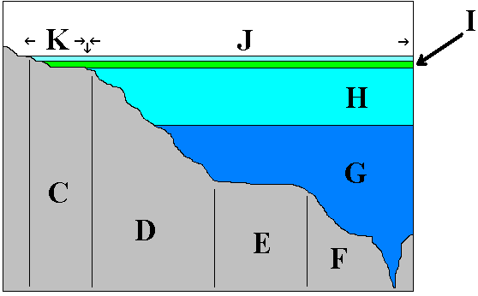
L

17) Collectively, what are zones C,D,E, F and L known as? ____________________________

18) Collectively, what are water zones G,H and I known as? ____________________________

19) What is the name of the light free zone represented by G? ____________________________

20) What zone, otherwise known as the “House of the Dead” is represented by F ___________________________

21) What is the name of the zone represented by L ____________________________

22) What is the name of the photosynthetic rich water zone that gets lots of light? ____________________________

